ASSIGNMENT 2

TEAM MEMBERS
TAMANNA SHARMA 20251502034
SIDDHI VYAS 20251501163
PRANJALI NAMA 20251502022
SHOBHIT RAI 20251502032
KRISH KUMAR 20251502015

ELEVATOR DISPATCH SYSTEM

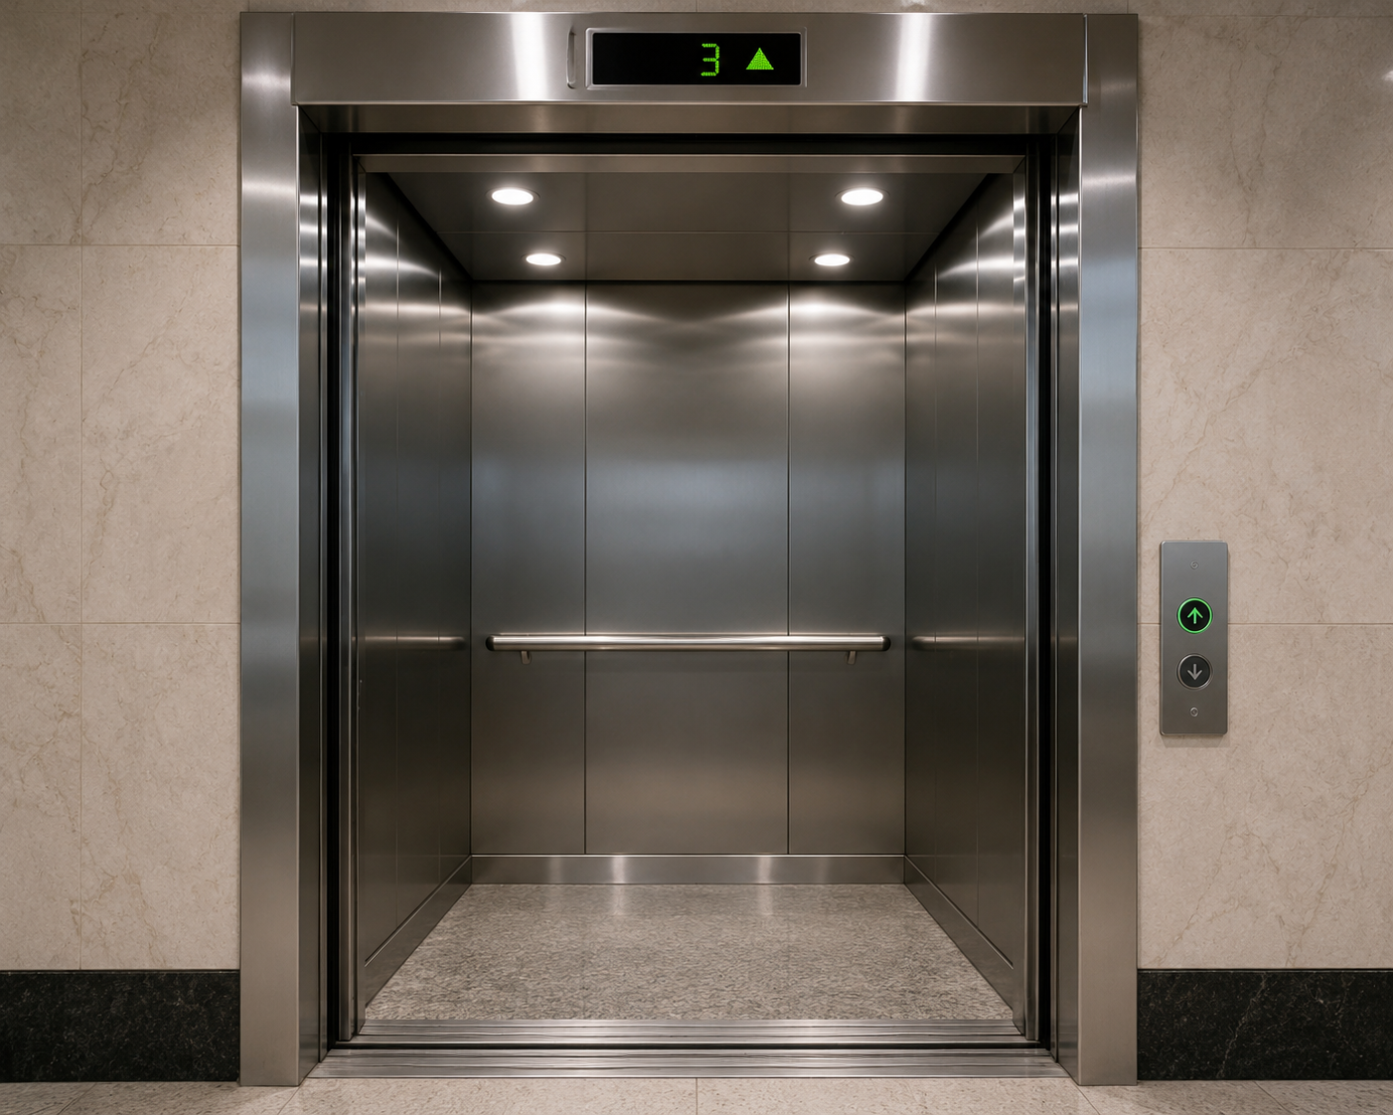

Raw candidate list
We first extract nouns from the three specifications as possible classes and verbs as possible responsibilities/operations.
Raw noun candidate
Passenger
Elevator
Floor
Direction
Call Button
Dispatch Algorithm
Elevator Status
Elevator Location
Response Time
Waiting Queue
Destination
Movement Command
Fault
Emergency
Emergency Button
Emergency Sensor
Emergency Event
Security
Maintenance Team
Building Administrator
Communication Channel
Building Management System
Passenger Request

Verb analysis
The important verbs indicate what the eventual classes need to do.
Verb/action | Possible responsibility
Request | Passenger requests an elevator
Press | Passenger presses call/emergency button
Detect | System detects requests/emergencies
Identify | System identifies floor, direction and elevator
Check | System checks elevator status
Evaluate | System evaluates available elevators
Select | System selects suitable elevator
Assign | System assigns request to elevator
Move | Elevator moves toward a floor
Update | System updates status/location
Notify | System notifies passenger/security
Enter | Passenger enters elevator
Exit | Passenger exits elevator
Calculate | System calculates response time
Compare | System compares elevators
Filter | System removes unavailable elevators
Record | System records requests/emergency events
Stop | System stops assigning requests to an affected elevator
Mark | System marks elevator unavailable
Search | System searches for another elevator
Reassign | System reassigns a request
Inspect | Maintenance inspects elevator
Resolve | Maintenance resolves the problem
Return | Elevator returns to normal service
For example, the Dispatch specification contains the sequence of retrieving elevator status, filtering unavailable elevators, calculating response time, comparing elevators, selecting one, and assigning the request.

C. Applying the four filters
For noun–verb analysis, we can use these four common filters:
- Redundant – duplicate/overlapping concept.
- Irrelevant – not important to the system's domain.
- Attribute – better represented as an attribute of another class.
- Implementation/detail – something that should not become a domain class.

Candidate | Filter | Reason
Direction | Attribute | Up/Down is an attribute of a Request
Floor | Attribute | A floor number can be an attribute of Request/Elevator
Elevator Status | Attribute | Status belongs to Elevator
Elevator Location | Attribute | Current floor/location belongs to Elevator
Response Time | Attribute | A calculated value associated with an Elevator/Request
Destination | Attribute | Destination floor belongs to Request
Movement Command | Implementation/detail | Command is an internal system action
Dispatch Algorithm | Implementation/detail | Algorithm is how dispatch is implemented
Call Button | Implementation/detail | Interface/device detail rather than a core domain class
Emergency Button | Implementation/detail | Input mechanism for an emergency
Emergency Sensor | Implementation/detail | Detection mechanism
Communication Channel | Implementation/detail | Communication mechanism
Building Management System | Irrelevant/External | Mentioned as a possible external information source, not central to these three use cases
Passenger Request | Redundant | Same conceptual entity as Request
Security | Irrelevant/External actor | Acts as an external recipient rather than a core domain class
Building Administrator | Irrelevant/External actor | Actor interacting with the system
Maintenance Team | Irrelevant/External actor | External actor responsible for maintenance
Fault | Attribute | Can be represented as an elevator's fault/emergency status

Candidates eliminated
Surviving classes
After applying the filters, I would keep these six core domain classes:

1. Passenger
Represents the person who requests and uses an elevator.

2. Elevator
Represents an individual elevator and its movement/status.

3. Request
Represents a passenger's request for an elevator.

4. Elevator Dispatch System
Represents the central system that receives requests and assigns elevators.

5. Emergency
Represents an emergency condition/event associated with an elevator.

6. Maintenance Staff
Represents the personnel who inspect and restore an elevator after a fault/emergency.

CRC Cards
Based on the five surviving classes from Question 1:
- Passenger
- Elevator
- Request
- Elevator Dispatch System
- Emergency
CRC stands for Class – Responsibilities – Collaborators.

CRC Card 1: Passenger

Class | Passenger
Responsibilities | Request an elevator  Specify the direction (Up/Down)  Enter the elevator  Select destination floor  Exit the elevator at the destination
Collaborators | Request, Elevator Dispatch System, Elevator
The specification states that the passenger presses the Up/Down button, enters the elevator, selects the destination, and exits at the correct floor.

CRC Card 2: Elevator

Class | Elevator
Responsibilities | Receive an assigned request  Move toward the requested floor  Stop at the requested floor  Maintain current location  Maintain operational status  Become unavailable during an emergency
Collaborators | Passenger, Request, Elevator Dispatch System, Emergency

The specifications describe the elevator being selected, assigned a request, receiving a movement command, travelling to the requested floor, and becoming unavailable during an emergency.

CRC Card 3: Request

Class | Request
Responsibilities | Store the passenger's elevator request  Store requested floor  Store direction  Maintain request status  Be assigned to an elevator  Wait in queue when no elevator is available
Collaborators | Passenger, Elevator, Elevator Dispatch System
The specification states that the system identifies the passenger's floor and requested direction, assigns the request to an elevator, and places it in a waiting queue if no elevator is available.

CRC Card 4: Elevator Dispatch System

Class | Elevator Dispatch System
Responsibilities | Receive elevator requests  Identify requested floor and direction  Check elevator location and status  Filter unavailable elevators  Calculate response time  Compare available elevators  Select the most suitable elevator  Assign requests to elevators  Update request/elevator status  Handle emergencies  Notify relevant personnel
Collaborators | Passenger, Request, Elevator, Emergency
This is the central class because it performs the main coordination work in all three specifications: receiving requests, selecting elevators, assigning requests, updating status, and handling emergencies.

CRC Card 5: Emergency

Class | Emergency
Responsibilities | Represent an emergency condition  Identify the affected elevator  Record the emergency  Cause the affected elevator to be removed from normal dispatching  Maintain emergency status until the situation is resolved
Collaborators | Elevator, Elevator Dispatch System

The specification says that when an emergency occurs, the affected elevator is identified, removed from normal dispatching, marked unavailable, and the emergency is recorded.

Object Diagram

@startuml
title Elevator Dispatch System - Object Diagram (Concrete Scenario)

skinparam shadowing false
skinparam objectBorderColor Black
skinparam objectBackgroundColor White

object "building1 : Building" as Building {
name = "IIITV Academic Block"
totalFloors = 10
}

object "dispatcher1 : ElevatorDispatchSystem" as Dispatcher {
algorithm = "LOOK"
status = "Operational"
activeRequests = 3
}

object "passenger1 : Passenger" as Passenger {
name = "Rahul"
currentFloor = 3
destinationFloor = 8
}

object "request1 : ElevatorRequest" as Request {
requestID = 1001
sourceFloor = 3
destinationFloor = 8
direction = "UP"
status = "Assigned"
requestTime = "10:15 AM"
}

object "elevator2 : Elevator" as Elevator {
elevatorID = "E2"
currentFloor = 5
direction = "DOWN"
status = "Moving"
capacity = 10
occupied = 4
}

object "door2 : Door" as Door {
state = "Closed"
}

object "display2 : DisplayPanel" as Display {
message = "Moving to Floor 3"
}

object "admin1 : BuildingAdministrator" as Admin {
name = "Mr. Sharma"
monitoring = true
}

object "maintenance1 : MaintenanceStaff" as Maintenance {
technician = "Rakesh"
availability = "Available"
}

object "scheduler1 : SystemTimer" as Timer {
maintenanceThreshold = 1000
usageCount = 742
nextHealthCheck = "11:00 AM"
}

object "fireAlarm1 : FireAlarmSystem" as FireAlarm {
status = "Inactive"
}

Building --> Dispatcher : contains
Building --> Elevator : installs

Passenger --> Request : creates
Dispatcher --> Request : manages
Dispatcher --> Elevator : dispatches

Elevator --> Door : controls
Elevator --> Display : updates

Admin --> Dispatcher : monitors
Maintenance --> Elevator : services

Timer --> Dispatcher : health check
Timer --> Elevator : usage monitoring

FireAlarm --> Dispatcher : emergency signal

@enduml

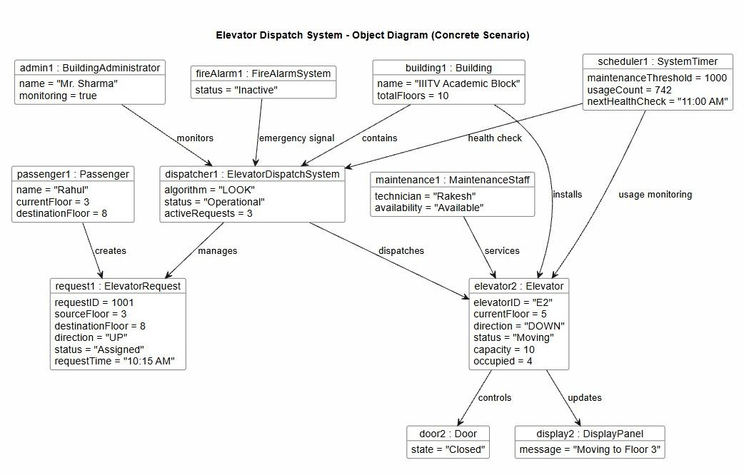

DOMAIN CLASS DIAGRAM

@startuml
skinparam classAttributeIconSize 0

class BuildingAdministrator {
- name: String
- monitoring: boolean
+ monitorSystem(): void
}

class FireAlarmSystem {
- status: String
+ triggerAlarm(): void
}

class Building {
- name: String
- totalFloors: int
}

class SystemTimer {
- maintenanceThreshold: int
- usageCount: int
- nextHealthCheck: String
+ triggerHealthCheck(): void
+ monitorUsage(): void
}

class Passenger {
- name: String
- currentFloor: int
- destinationFloor: int
+ pressButton(): void
}

class ElevatorDispatchSystem {
- algorithm: String
- status: String
- activeRequests: int
+ assignRequest(r: ElevatorRequest): void
+ updateStatus(): void
+ handleEmergency(): void
}

class MaintenanceStaff {
- technician: String
- availability: String
+ serviceElevator(e: Elevator): void
}

class ElevatorRequest {
- requestID: int
- sourceFloor: int
- destinationFloor: int
- direction: String
- status: String
- requestTime: String
+ updateStatus(newStatus: String): void
}

class Elevator {
- elevatorID: String
- currentFloor: int
- direction: String
- status: String
- capacity: int
- occupied: int
+ move(): void
+ stop(): void
+ openDoor(): void
+ closeDoor(): void
+ updateDisplay(): void
}

class Door {
- state: String
+ open(): void
+ close(): void
}

class DisplayPanel {
- message: String
+ showMessage(msg: String): void
}

' Associations and Multiplicities
BuildingAdministrator "1" -- "1" ElevatorDispatchSystem : monitors >
FireAlarmSystem "1" -- "1" ElevatorDispatchSystem : emergency signal >
Building "1" -- "1" ElevatorDispatchSystem : contains >
Building "1" -- "1..*" Elevator : installs >
SystemTimer "1" -- "1" ElevatorDispatchSystem : health check >
SystemTimer "1" -- "1..*" Elevator : usage monitoring >
Passenger "1..*" -- "1..*" ElevatorRequest : creates >
ElevatorDispatchSystem "1" -- "0..*" ElevatorRequest : manages >
ElevatorDispatchSystem "1" -- "1..*" Elevator : dispatches >
MaintenanceStaff "1..*" -- "1..*" Elevator : services >
Elevator "1" -- "1" Door : controls >
Elevator "1" -- "1..*" DisplayPanel : updates >

@enduml

